Oak Ridges Moraine Land Trust Activity Guide for Teachers
Activity: Toilet Paper Tube Binoculars Birdwatching Adventure
Age range: JK-Grade 2

Background:
- Encourage students to get outside and appreciate the wildlife around them with this fun binocular craft and imaginary birdwatching adventure! Students can identify some of the familiar birds that they’ve seen around their neighbourhoods in parks and yards. Encourage children to make connections between the animals they know and why wildlife is important.
Supplies:
- Toilet paper tubes (two per student)
- Tape
- Yarn
- Bird photo cutouts
- Writing paper (one sheet per student)
- Pencils (one per student)

Instructions:
- Tape two toilet paper tubes together.
- Measure out an appropriate length of yarn to make a strap for students to safely wear the binoculars around their necks.
- Tape the yarn to the side of the binoculars to attach the strap.
- Scatter photos of familiar birds like robins and cardinals around the room.
- Using their new binoculars, students will go on a birdwatching adventure around the classroom, looking for all the different birds they can find and writing their names down on a list.
- When the birding adventure is over, students can share with the class which birds they found. Facilitate a discussion about birds based on the following questions.

Inquiry-based learning questions:
- Have you ever watched birds before?
- Have you ever looked at birds at a birdfeeder?
- Which of these birds do you know the names of?
- What places do you see wildlife?
- Is there wildlife outside your windows at home?
- What are some ways that people enjoy nature?
- Where are some of the places we’ve gone camping or hiking?

Curriculum Connections:

The Kindergarten Program (2016):

• Problem Solving and Innovating:
exploring the world through natural curiosity, in ways that engage the mind, the senses, and the body;
• making meaning of their world by asking questions, testing theories, solving problems, and engaging in creative and analytical thinking;
• the innovative ways of thinking about and doing things that arise naturally with an active curiosity, and applying those ideas in relationships with others, with materials, and with the environment.

Grade 1:

• B. Life Systems - Needs and Characteristics of Living Thing
• B1. Relating Science and Technology to Our Changing World - assess the importance of a healthy environment for living and non-living things, and the responsibilities of humans in contributing to a healthy environment
• B2. Exploring and Understanding Concepts - demonstrate an understanding of the basic needs and characteristics of living things, including humans

Grade 2:
• Life Systems - Growth and Changes in Animals

• B1. Relating Science and Technology to Our Changing World - assess ways in which animals have an impact on society and the environment, and ways in which human activities have an impact on animals and the places where they live
• B2. Exploring and Understanding Concepts - demonstrate an understanding that animals grow and change and have distinct characteristics

Bird Photo List:
- Blue Jay
- American Crow
- American Robin
- Mallard
- Mourning Dove
- Great Blue Heron
- Northern Cardinal
- Canada Goose
- Black-capped Chickadee
- Ruby-throated Hummingbird

Craft example:
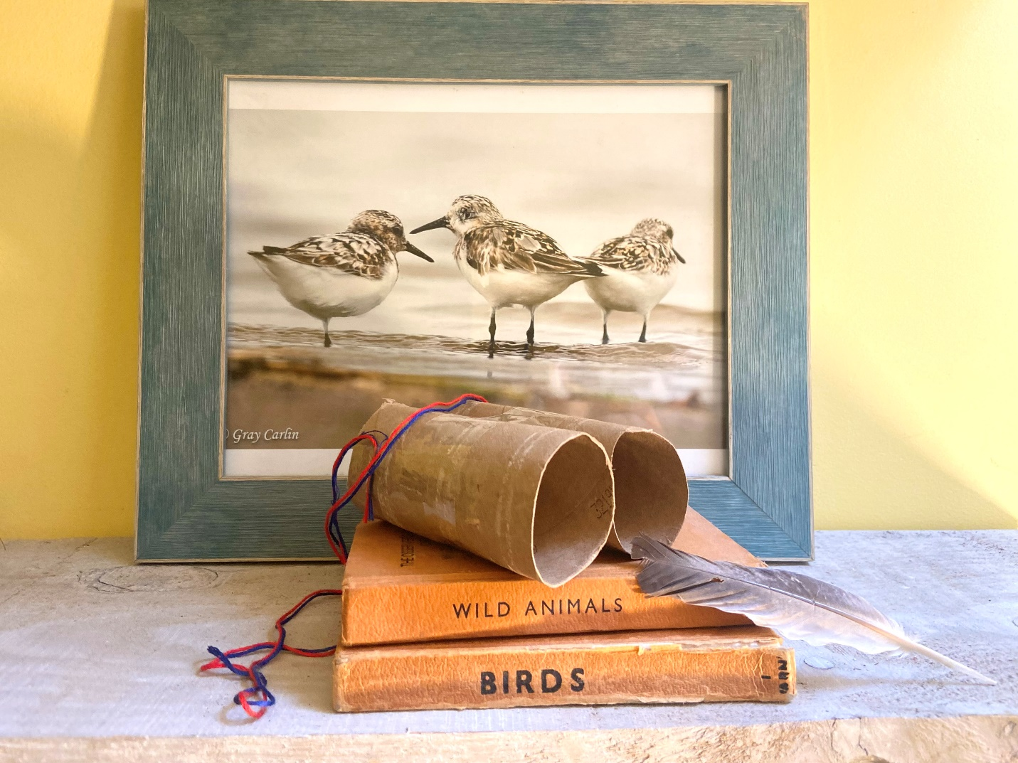

American Crow
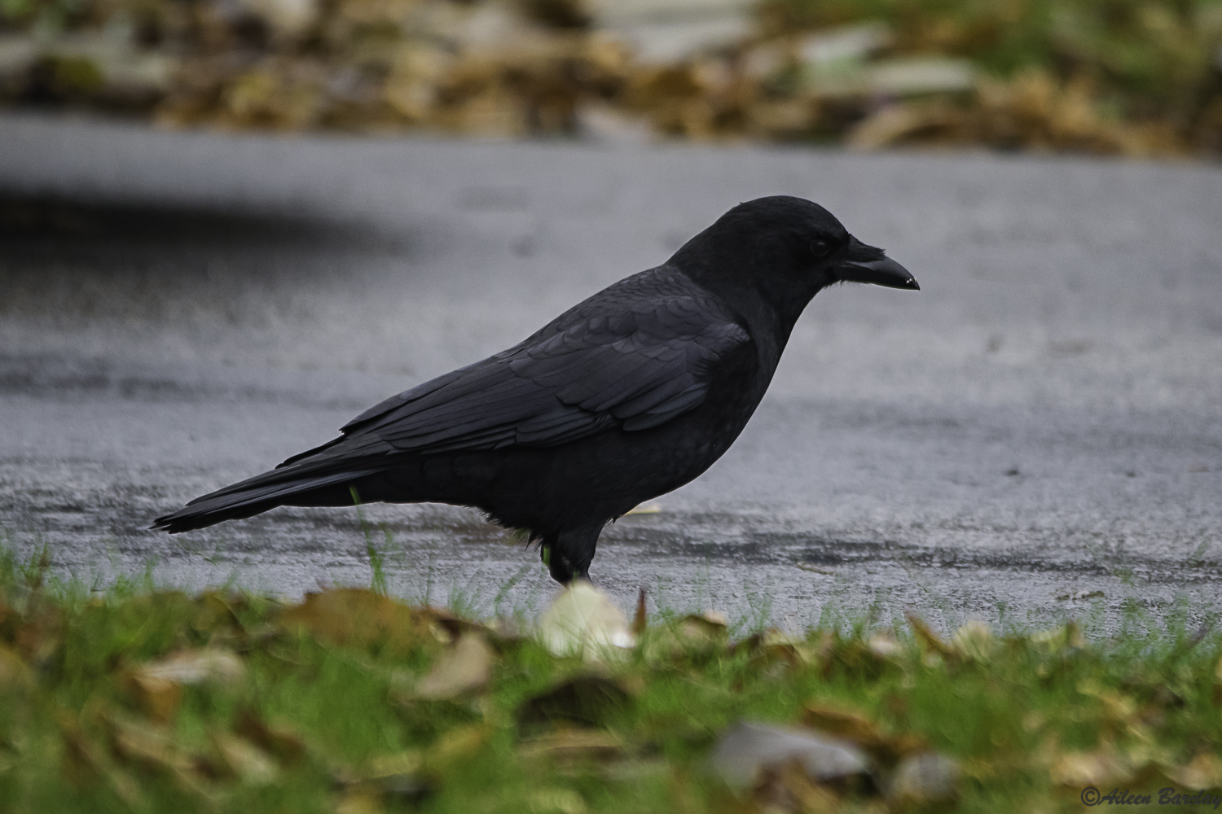

American Robin
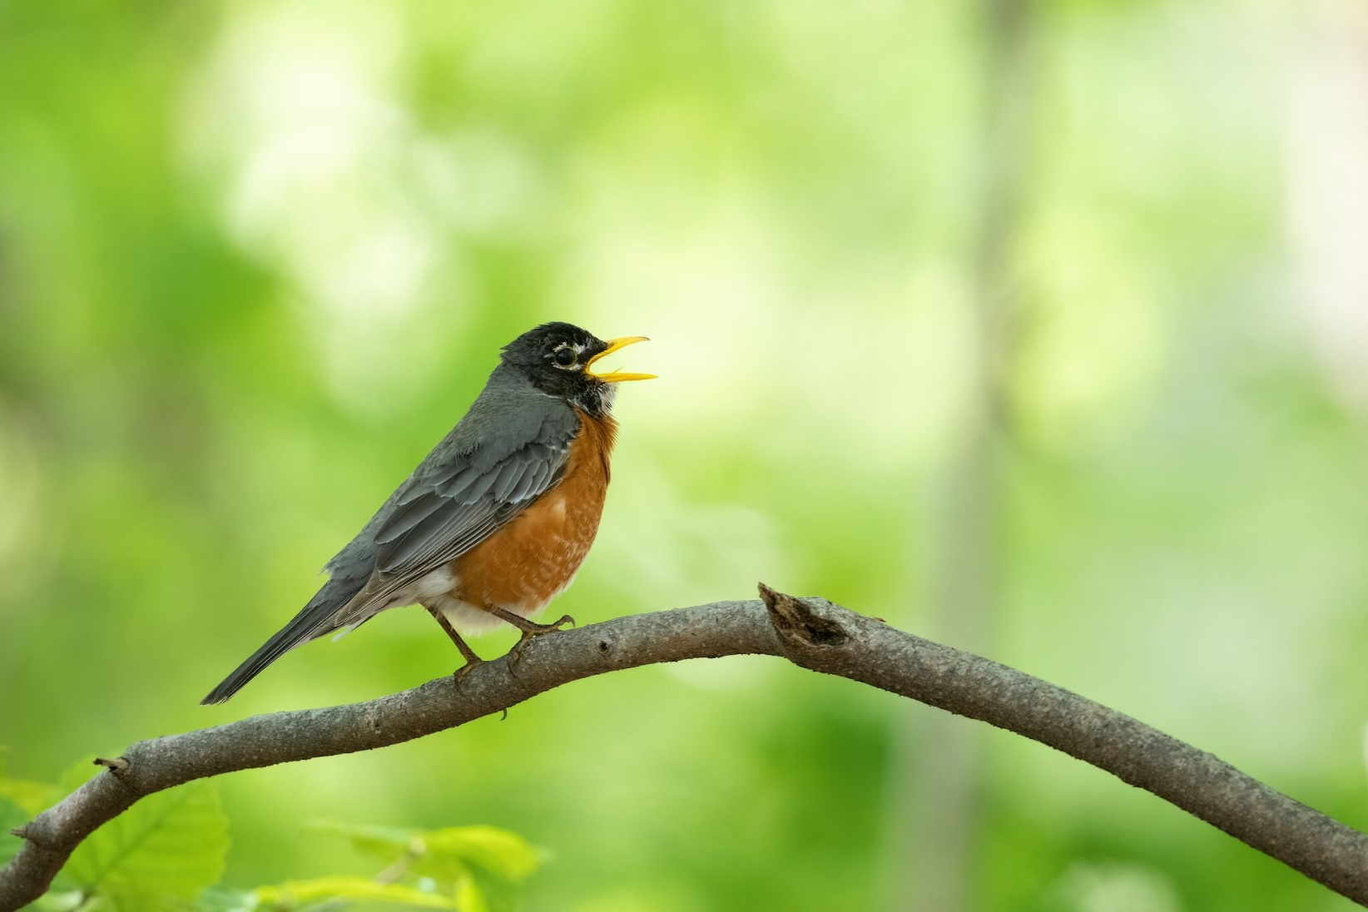

Ruby-throated Hummingbird
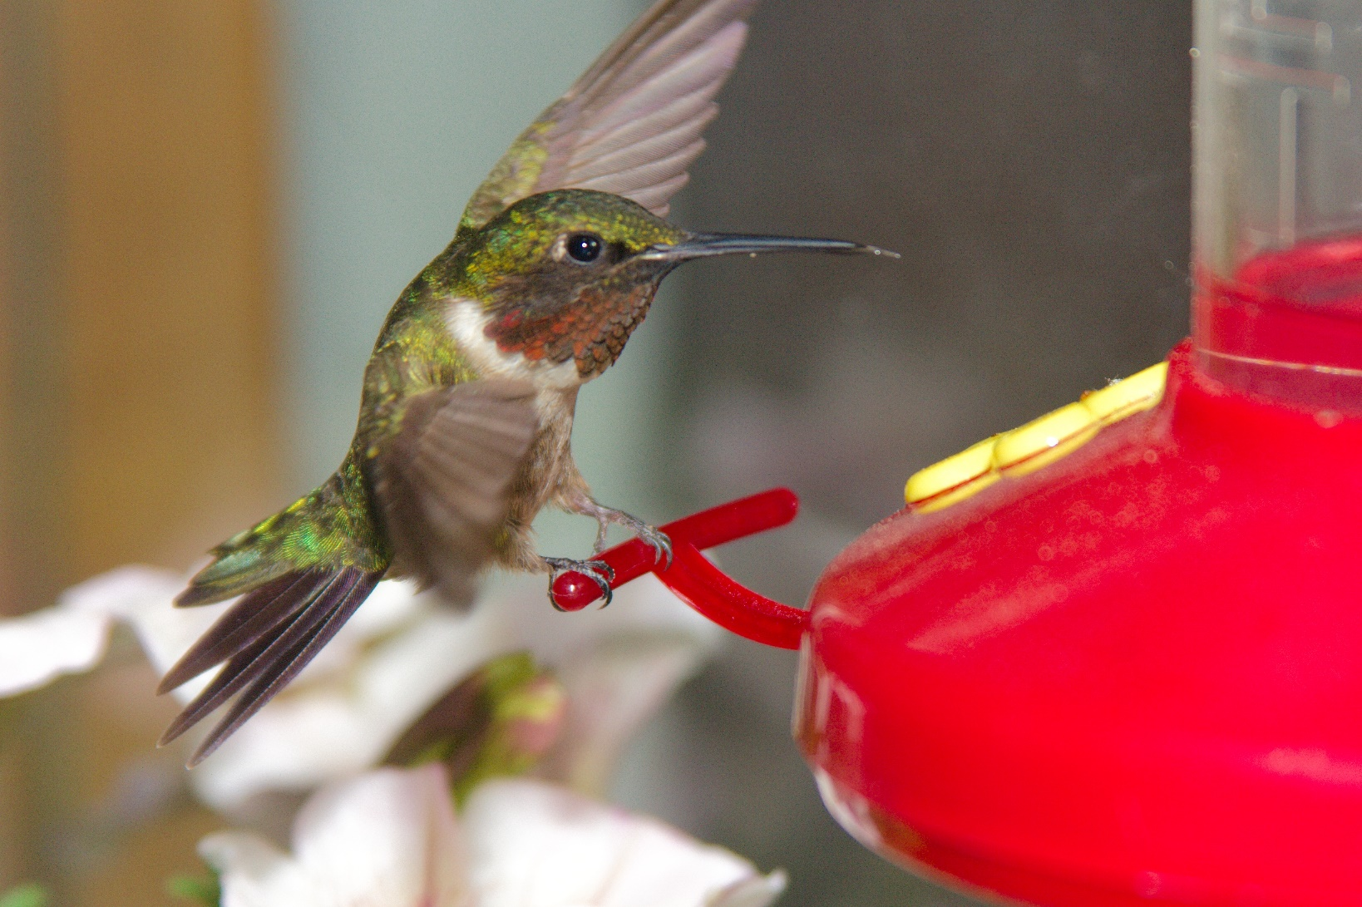

Black-capped Chickadee
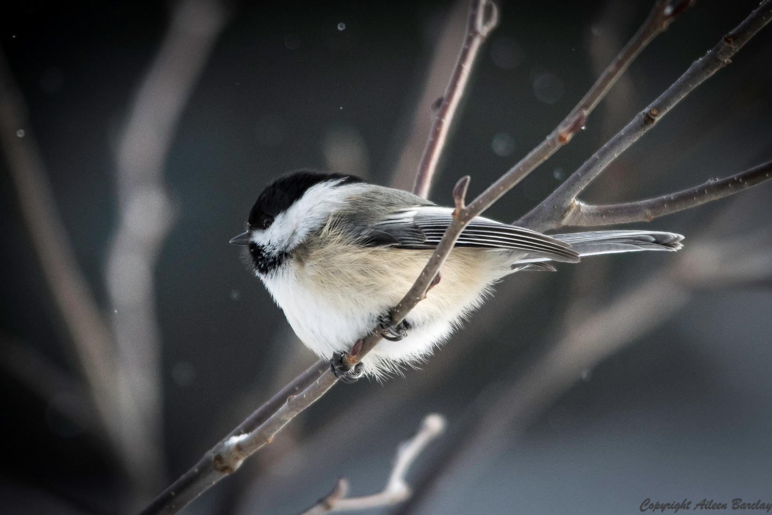

Northern Cardinal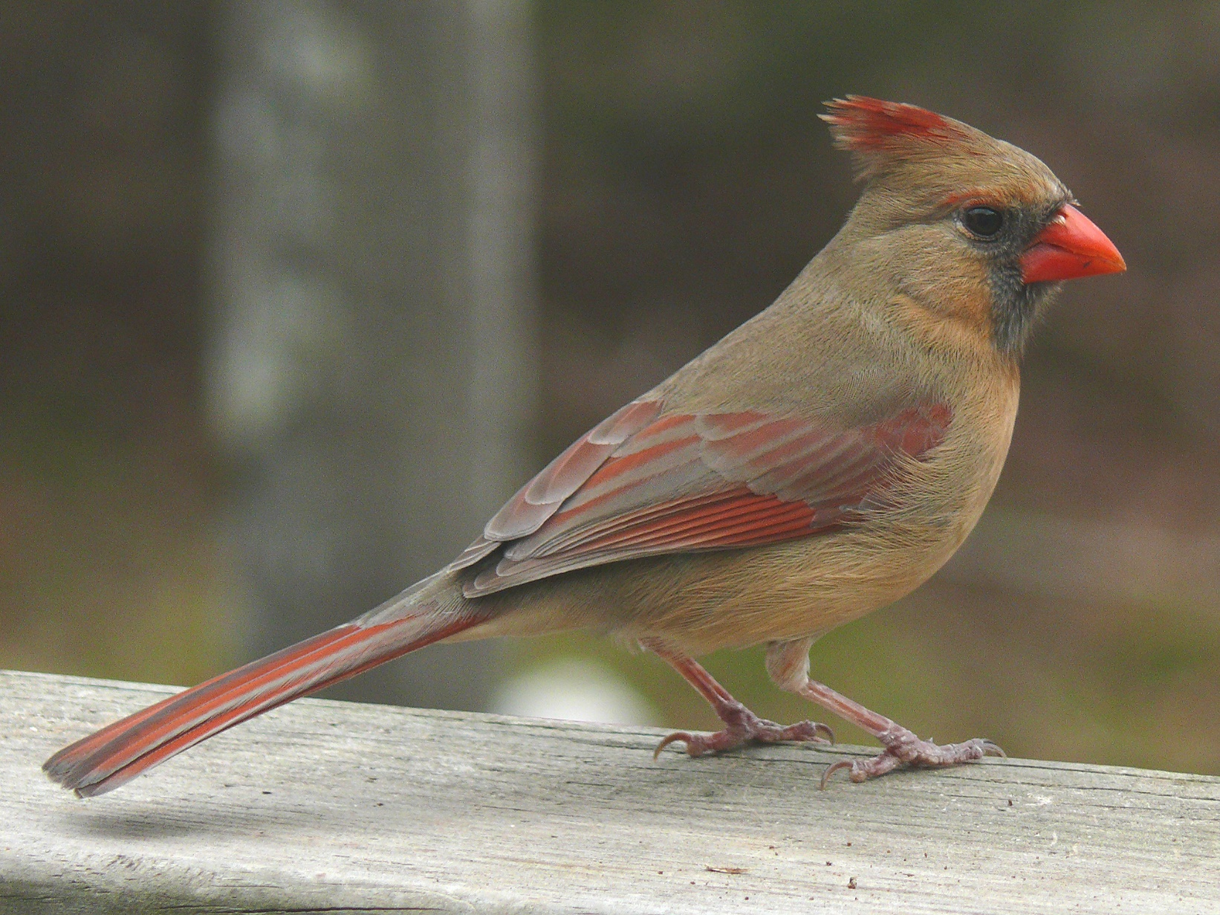

Mallard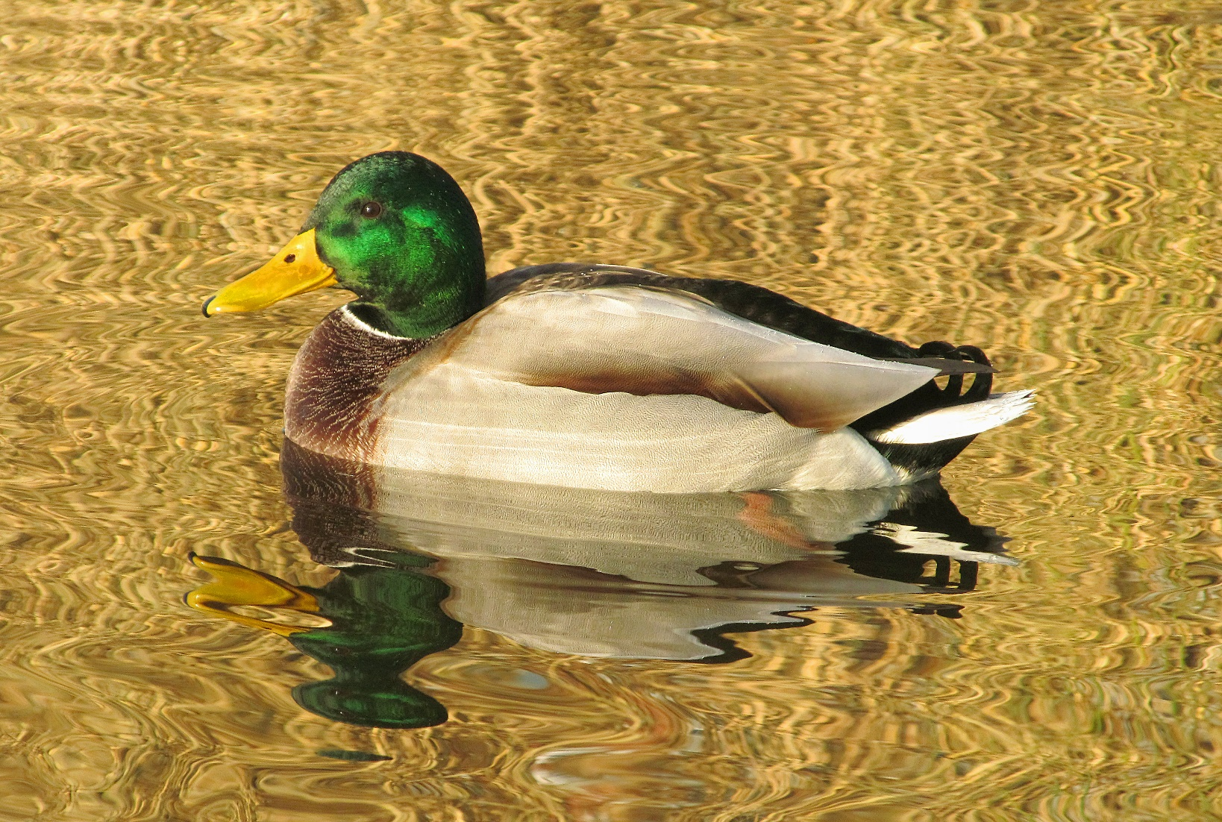

Mourning Dove
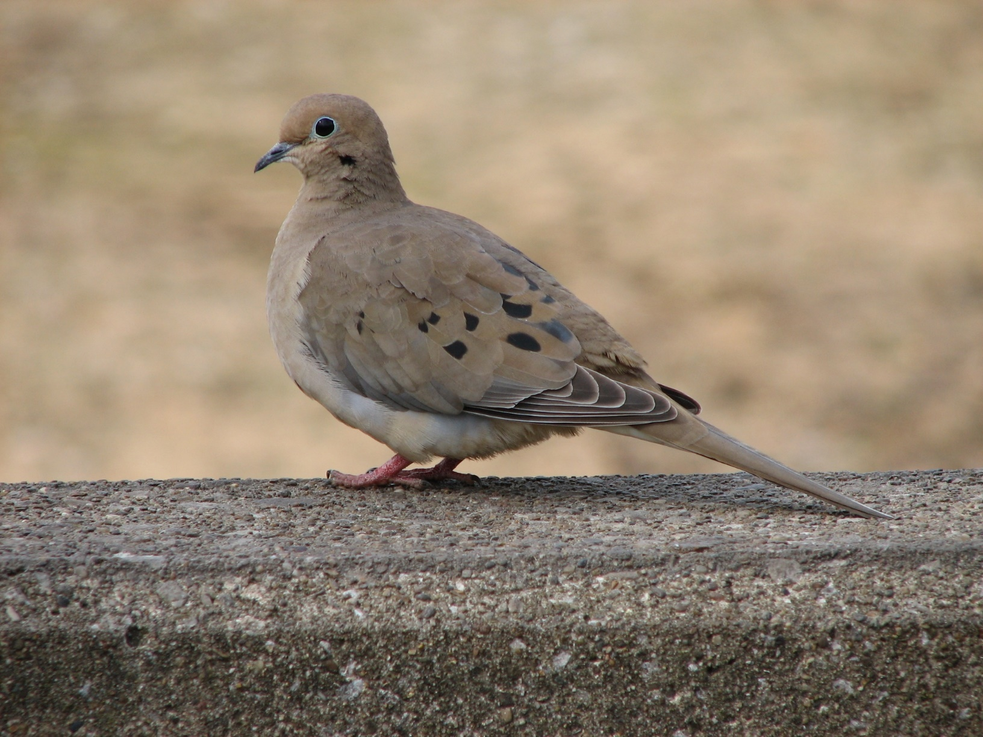

Canada Goose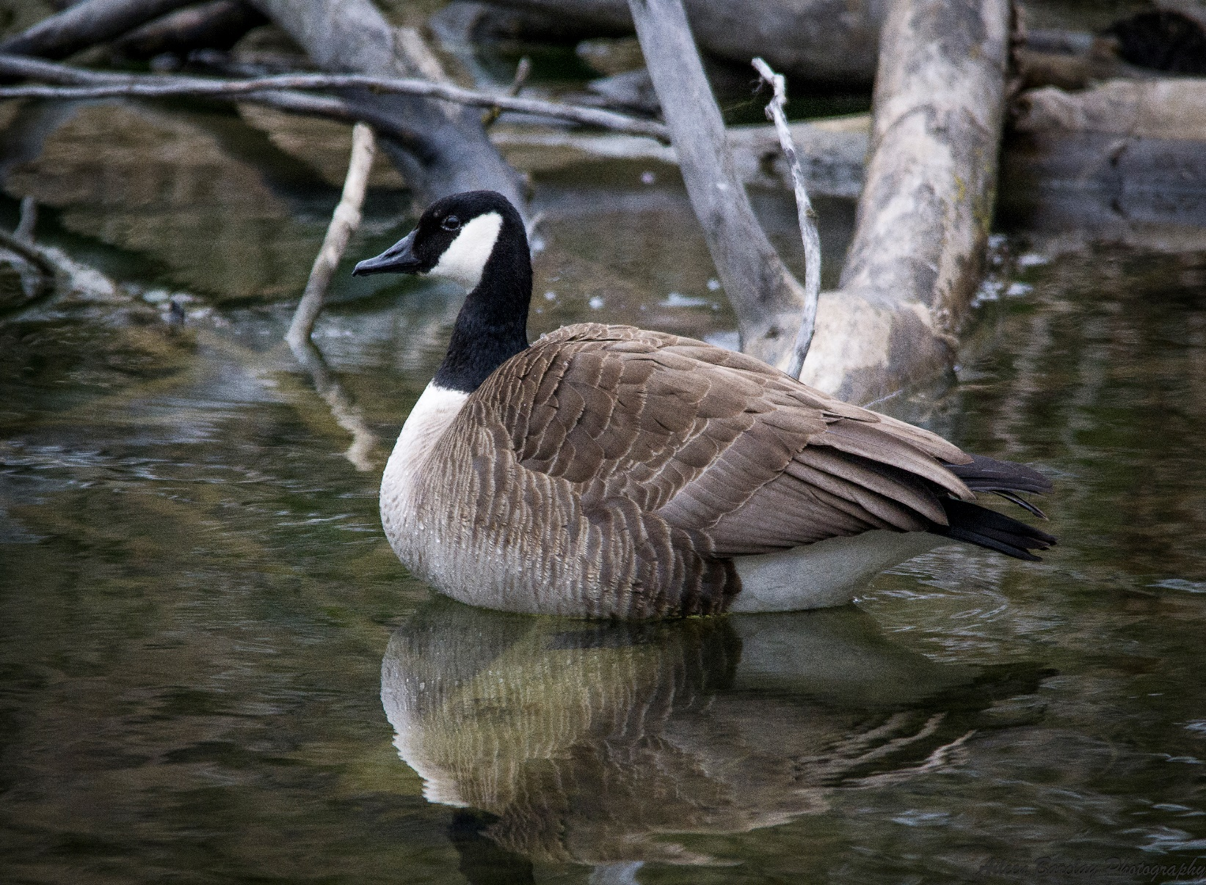
Great Blue Heron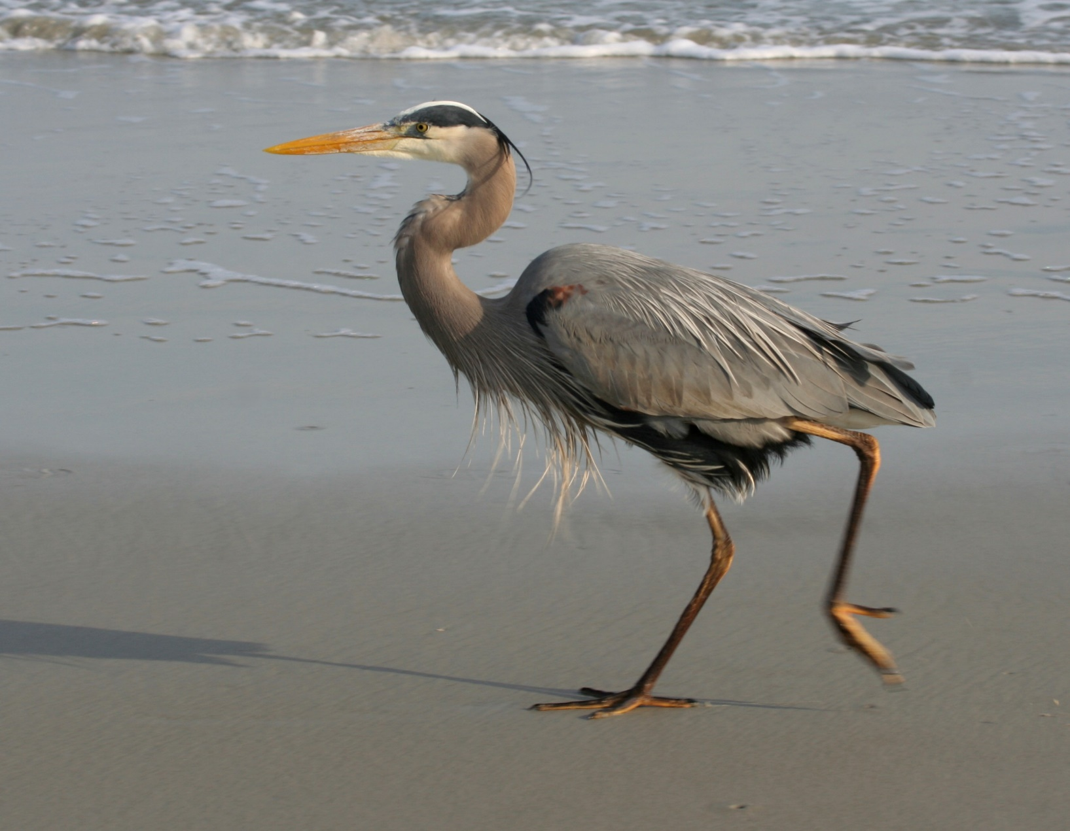Blue Jay